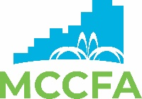

Progress | Hospitality | Growth

MONTGOMERY COUNTY CONVENTION FACILITIES AUTHORITY
BOARD OF DIRECTORS

Executive Committee Meeting

Wednesday, November 19, 2025 | 3:00 p.m. - 4:00 p.m.
By Electronic/Telephonic Means – Contact Adrianna Templeton at
atempleton@montgomerycountycfa.org 937-522-5724 for virtual meeting information

AGENDA

I. Roll Call – Call Meeting to Order Action

II. Executive Session – The committee will adjourn to executive session to Action
consider the compensation of a public employee, pursuant to the authority set out at Ohio Revised Code Section 121.22(G)(1).

III. Other Business Information

IV. Next Meeting Date: TBD Information

V. Adjournment Action

For Additional Information, Contact atempleton@montgomerycountycfa.org | 937-522-5724

