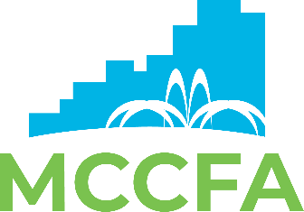

MONTGOMERY COUNTY CONVENTION FACILITIES AUTHORITY
BOARD OF DIRECTORS

CMAR Selection Committee Meeting
February 24, 2022
3pm - 5pm - via In Person CFA Boardroom

AGENDA

- Roll Call

- Review of CMAR Selection Committee Meeting Minutes -
January 31, 2022 Action

- Agenda

  - Review of CMAR Referral Responses Received Information

  - Review of Side-by-Side Cost Analysis Comparison Information

  - Score Evaluation Performance & Pricing Criteria - All Five Firms -
and Recommend Successful Bidder Action

- Other Business

- Next Meeting Date: N/A - In Conjunction with Regular Board Meeting - March 3, 2022

- Adjournment

