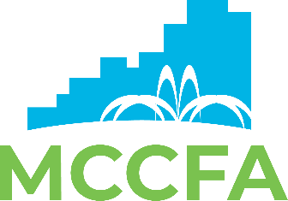

MONTGOMERY COUNTY CONVENTION FACILITIES AUTHORITY
BOARD OF DIRECTORS

CMAR Selection Committee Meeting
January 31, 2022
4pm - 5:30pm - via In Person & Electronic Means

AGENDA

- Roll Call

- Agenda

  - Review of RFQ Qualifications Matrix Information

  - Review and Score RFP Responses from Five Firms Action

  - Review of RFP Draft/Evaluation Matrix and Next Steps Information

- Other Business

- Next Meeting Date: February 24, 2022 - 9am - 5pm - Interview Firms and Deliberation

- Adjournment

